**Question 1:**

Create a shell file which includes Installation of Tomcat 9(into new directory) and start tomcat service Execute created shell file which should install and start service **Output**: Launch Tomcat from browser (It should launch default page) **Note**: Tomcat Requires Java as Pre-requisite and Tomcat runs on Port 8080 by default

**Ans:** 1. First create an EC2-Instance

2. Connect to any terminal lets say windows powershell by .pem file

3. Now the first command **[sudo dnf -y update]** this updates the VM, dnf- defined yum and sudo means giving root permissions.

4. Now we are installing java which version supports your tomcat server. In the current case it supports java-1.8

[**sudo dnf install java-1.8*]** * indicates install all supporting packages for java

[**java -version]** to check which version has been installed

5. Now **[sudo dnf install wget]** To download any appalication directly from internet

6**. [wget** [**https://archive.apache.org/dist/tomcat/tomcat-10/v10.0.23/bin/apache-tomcat-10.0.23.tar.gz**](https://archive.apache.org/dist/tomcat/tomcat-10/v10.0.23/bin/apache-tomcat-10.0.23.tar.gz)**]** now zipped file has been downloaded.

**[tar xvzf apache-tomcat-10.0.23.tar.gz]** to unzip the data.

7. **[mv apache-tomcat-10.0.23/ tomcat]** To move the whole unzip data to another folder

8 **[ls]** To check the lists

9 **[cd bin/]** To get into that particular folder

10.**[sh startup.sh]** To start the tomcat server.

Now that tomcat server is downloaded and running on EC2 VM.

11. Now we edit in bound rules in the security groups

Type – Custom TCP

Port – 8080

12. Now everything is done and lets check the connection. Copy paste the IPv4 public IP address and paste it on portal with :8080 Ex our IP address is [54.163.22.167:8080](http://54.163.22.167:8080)

**Question 2:** Create a file (test.txt) with content as ""I love machine, I am into devops cloud"" Write a shell script which has to replace machine into DevOps in above file Then print the no of occurences of devops as output when we execute shell file

**Ans:**

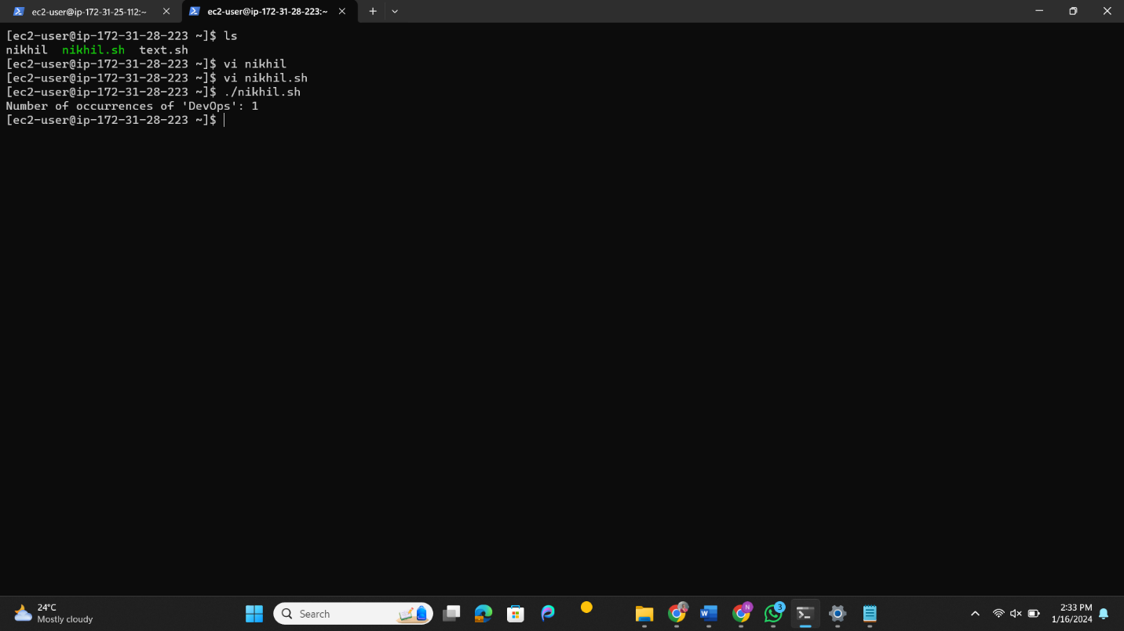

And chmod +x filename to give permissions for execution